TASK 7.1:
PROGRAM:
class ParkingSystem {
private int[] cnt;
public ParkingSystem(int big, int medium, int small) {
cnt = new int[] {0, big, medium, small};
}
public boolean addCar(int carType) {
if (cnt[carType] == 0) {
return false;
}
cnt[carType]--;
return true;
}
}
OUTPUT:
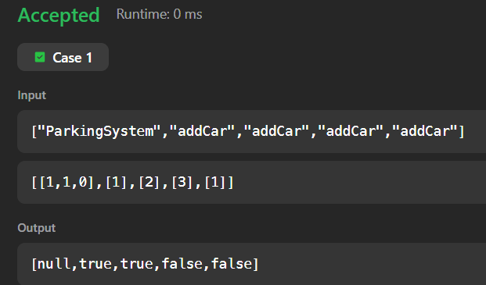
TASK7.2:
PROGRAM:
import java.util.*;

class Student{}
class Rockstar{ }
class Hacker{}
public class InstanceOFTutorial{
static String count(ArrayList mylist){
int a = 0,b = 0,c = 0;
for(int i = 0; i < mylist.size(); i++){
Object element=mylist.get(i);
if(element instanceof Student)
a++;
if(element instanceof Rockstar)
b++;
if(element instanceof Hacker)
c++;
}
String ret = Integer.toString(a)+" "+ Integer.toString(b)+" "+ Integer.toString(c);
return ret;
}
public static void main(String []args){
ArrayList mylist = new ArrayList();
Scanner sc = new Scanner(System.in);
int t = sc.nextInt();
for(int i=0; i<t; i++){
String s=sc.next();
if(s.equals("Student"))mylist.add(new Student());
if(s.equals("Rockstar"))mylist.add(new Rockstar());
if(s.equals("Hacker"))mylist.add(new Hacker());
}
System.out.println(count(mylist));
}
}
OUTPUT:
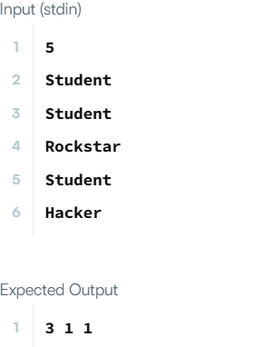
TASK7.3:
PROGRAM:
class UndergroundSystem {
private Map<Integer, Pair<String, Integer>> checkInMap;
private Map<String, int[]> journeyMap; // Key: "start->end", Value: [totalTime, count]
public UndergroundSystem() {
checkInMap = new HashMap<>();
journeyMap = new HashMap<>();
}
public void checkIn(int id, String stationName, int t) {
checkInMap.put(id, new Pair<>(stationName, t));
}
public void checkOut(int id, String stationName, int t) {
Pair<String, Integer> checkIn = checkInMap.remove(id);
String startStation = checkIn.getKey();
int startTime = checkIn.getValue();
int travelTime = t - startTime;
String routeKey = startStation + "->" + stationName;
journeyMap.putIfAbsent(routeKey, new int[2]);
int[] stats = journeyMap.get(routeKey);
stats[0] += travelTime; // total time
stats[1] += 1; // trip count
}
public double getAverageTime(String startStation, String endStation) {
String routeKey = startStation + "->" + endStation;
int[] stats = journeyMap.get(routeKey);
return (double) stats[0] / stats[1];
}
}
OUTPUT:
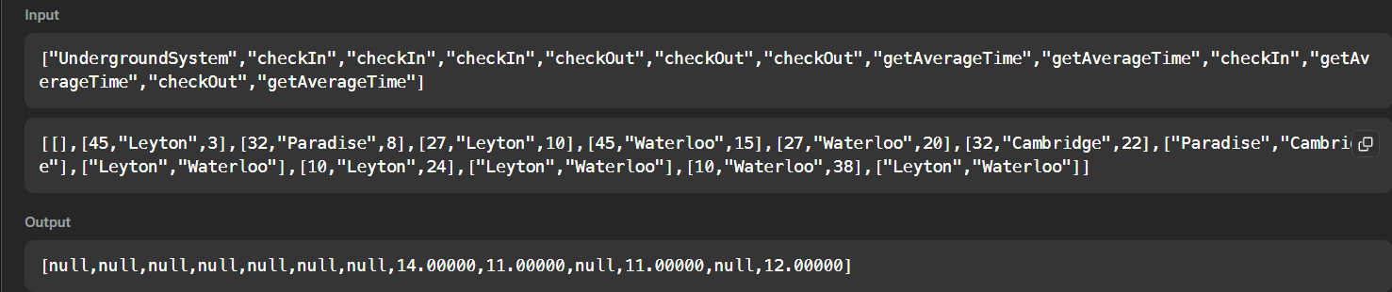TASK7.4:
PROGRAM:
class BrowserHistory {
private List<String> history;
private int currentIndex;
public BrowserHistory(String homepage) {
history = new ArrayList<>();
history.add(homepage);
currentIndex = 0;
}
public void visit(String url) {
// Clear forward history
while (history.size() > currentIndex + 1) {
history.remove(history.size() - 1);
}
history.add(url);
currentIndex++;
}
public String back(int steps) {
currentIndex = Math.max(0, currentIndex - steps);
return history.get(currentIndex);
}
public String forward(int steps) {
currentIndex = Math.min(history.size() - 1, currentIndex + steps);
return history.get(currentIndex);
}
}
OUTPUT:
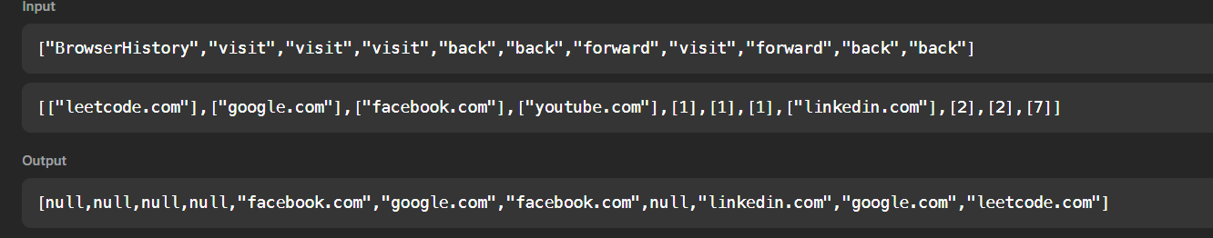TASK7.5:
PROGRAM:
class MyHashSet {
private static final int NUM_BUCKETS = 1999;
private List<Integer>[] buckets;

public MyHashSet() {
buckets = new LinkedList[NUM_BUCKETS];
for (int i = 0; i < NUM_BUCKETS; i++) {
buckets[i] = new LinkedList<>();
}
}

private int hash(int key) {
return key % NUM_BUCKETS;
}

public void add(int key) {
int h = hash(key);
if (!buckets[h].contains(key)) {
buckets[h].add(key);
}
}

public void remove(int key) {
int h = hash(key);
buckets[h].remove(Integer.valueOf(key));
}

public boolean contains(int key) {
int h = hash(key);
return buckets[h].contains(key);
}
}

OUTPUT:
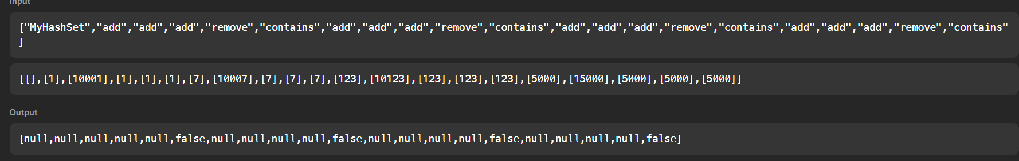
TASK7.6:
PROGRAM:
import java.io.*;
import java.math.*;
import java.security.*;
import java.text.*;
import java.util.*;
import java.util.concurrent.*;
import java.util.function.*;
import java.util.regex.*;
import java.util.stream.*;
import static java.util.stream.Collectors.joining;
import static java.util.stream.Collectors.toList;

class Result {

/*
* Complete the 'gradingStudents' function below.
*
* The function is expected to return an INTEGER_ARRAY.
* The function accepts INTEGER_ARRAY grades as parameter.
*/

public static List<Integer> gradingStudents(List<Integer> grades) {
List<Integer> result = new ArrayList<>();
for (int grade : grades) {
if (grade >= 38) {
int remainder = grade % 5;
if (remainder >= 3) {
grade += (5 - remainder);
}
}
result.add(grade);
}
return result;

}

}

public class Solution {
public static void main(String[] args) throws IOException {
BufferedReader bufferedReader = new BufferedReader(new InputStreamReader(System.in));
BufferedWriter bufferedWriter = new BufferedWriter(new FileWriter(System.getenv("OUTPUT_PATH")));

int gradesCount = Integer.parseInt(bufferedReader.readLine().trim());

List<Integer> grades = IntStream.range(0, gradesCount).mapToObj(i -> {
try {
return bufferedReader.readLine().replaceAll("\\s+$", "");
} catch (IOException ex) {
throw new RuntimeException(ex);
}
})
.map(String::trim)
.map(Integer::parseInt)
.collect(toList());

List<Integer> result = Result.gradingStudents(grades);

bufferedWriter.write(
result.stream()
.map(Object::toString)
.collect(joining("\n"))
+ "\n"
);

bufferedReader.close();
bufferedWriter.close();
}
}
OUTPUT:
